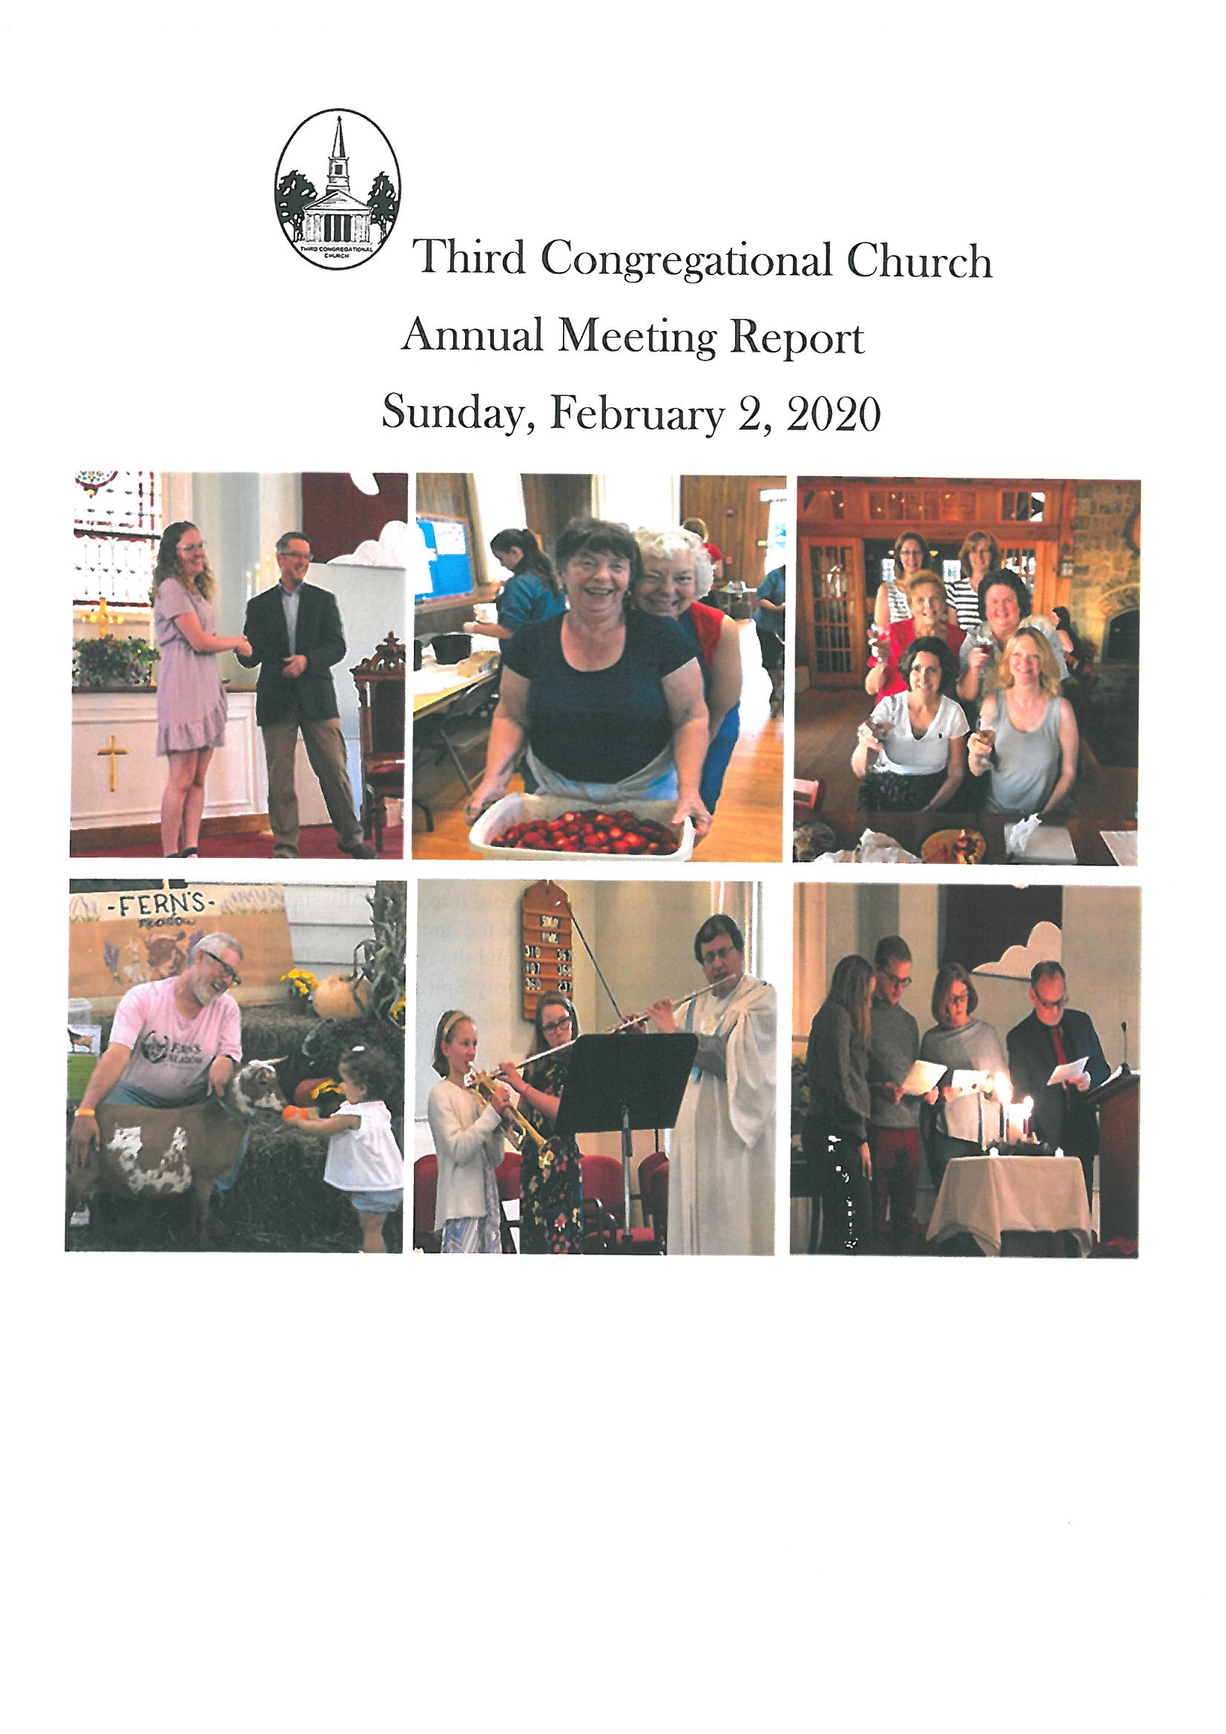

**OUR VISION**

* Sharing Christ's message of love, acceptance and forgiveness by: *

* Creating a comfortable environment of Christian fellowship open to all. *

* Celebrating God's love for the world through prayer, reflection, teaching and song *

* Advancing spiritual growth through dynamic ministries for all ages *

* Serving our world community near and far. *

**Covenant**

We are united in striving to know the will of God as taught in the Holy Scriptures, and in our purpose to walk in the ways of the Lord, made known or to be made known to us. We hold it to be the mission of the Church of Christ to proclaim the Gospel to all mankind, exalting the worship of the one true God, and laboring for the progress of knowledge, the promotion of justice, the reign of peace and the realization of human brotherhood. Depending, as did our fathers, upon the continued guidance of the Holy Spirit to lead us all in truth, we work and pray for the transformation of the world into the Kingdom of God; and we look with faith for the triumph of righteousness and the life everlasting.

Third Congregational Church of Middletown, CT

246th Annual Meeting Agenda

Sunday, February 2, 2020

* Call to Order
* Invocation
* Declaration of Quorum *(13 Regular Members Required, 127 named members at present)*
* Acceptance of Minutes
* Annual Meeting – February 3, 2019
* Special Meeting – October 20, 2019
* Old Business
* Reports of Officers, Boards and Committees
  + President
  + Pastor
  + Membership Report
  + Diaconate Report
  + Board of Christian Education
  + Board of Trustees
  + Treasurer’s Report
  + Board of Music
  + Board of Missions and Outreach
  + Board of Endowments
  + Stewardship Committee
  + Partnership for Sharing
* Other Reports
  + Westfield Ladies Aid Society
  + Reception Committee
  + Flower Committee
  + Garden Committee
  + Membership, Marketing & Communication
  + Westfield Community Celebration
  + Search Committee
  + Bylaws Report
  + Boy Scout Troop 16
  + Cub Scout Pack 43
* New Business
* 2020 Proposed Budget
* Bylaw Changes
* Elections
  + Nominating Committee Report
  + Nominations from the floor
* Remembrance
* Passing of the Gavel
* Benediction
* Adjournment

*Third Congregational Church of Middletown, CT*

*245th Annual Meeting Minutes*

*Sunday, February 3, 2019*

*\*\*\* R E V I S E D \*\*\**

The 245th Annual Meeting was called to order by Jeff Yardis at 11:29 a.m. Pastor Nancy Lois opened the meeting with a prayer.

Attendance was taken and a quorum declared with 45 active members present (attached). A motion for acceptance of the Minutes of the 244th Annual meeting on February 4, 2018 with changes was made by Dolores Sutton and seconded by Cookie Stojak. Special Meeting Notes on 10/28/18 was accepted by Dean Coutsouridis and seconded by Martha Fetter. Motion was in favor by all.

Jeff Yardis received the gavel in our past year as President and amongst his remarks that followed conveyed a focus on our membership and to hold a 2nd Festival on our grounds (likely minus the carnival rides) with a renewed focus on PFS events, and the statement that “Every Sunday is Rally Sunday!”

Discussions:

* Jeff Yardis: Russ Hassmann presented a spreadsheet last year that provided a great deal of financial data over the past 24 years which showed pledges, pledging families, endowment balances and annual growth and withdrawal. (This was a very helpful illustration as it encapsulated so many things that I found thought-provoking and useful in understanding our current issues and I would like to see this documented updated each year and be included in our annual report.)
* Cathy Mitchell: Pointed out that John Bagley voted “No” on the budget last year and this was noted mentioned in the Annual Report. She also stated that the Bylaws states “list all revenues” and that is also not in the Treasury Report. “This is not a Legal Annual Meeting”. This discussion was further discussed amongst Congregation members and was decided that this would be further discussed at a Trustee’s meeting. Further research into this could be obtained at that particular meeting.
* Robert Mitchell: “Ladies Aid in not in Treasury Report yet they hold events that donate to the Church”. This should be in Treasury Report. Sharon Maloney explained that the Westfield Ladies Aid is a separate entity and not a part of Third Congregational Church. They donate their proceeds from their events to support our Church. This was also tabled to be further researched to the Trustee’s meeting.
* A motion was made by Bill Ginter to “Remove Ladies Aid from the Annual Report”. Larry Cummings seconded it. All in favor
* Dana Andrew: “I feel that Ladies’ Aid should be kept a part of the Annual Report. They have been a contributing factor to Church for many years and felt that there is no need to exclude them.” It seems that if the Bylaws are not in agreement with the Treasury Report than there should be a Bylaw meeting to amend changes. Motion was made to keep Ladies’ Aid in the report and Russ Hassmann seconded it. All in favor. 1 abstention. Motion to remove Ladies Aid from the Annual Report was defeated by unanimous vote, with 1 abstention.
* Larry Cummings: Expressed an amazing job that Sharon Maloney did on Treasury Report.
* A motion was made to accept Treasury Report by Kim Kennedy and seconded by Dean Coutsouridis (1 abstained). All in favor.
* A motion was made by Russ Hassmann to accept the 2019 Budget and seconded by Dean Coutsouridis. All in favor. (1 abstained)
* A motion was made by Paul Kennedy to accept Board Reports in Annual Report and seconded by Dolores Sutton (1 abstained). All in favor.
* Ken Joy: “The Fellowship Committee is not on the Nominating Slate”. Sharon Maloney made a motion to put the Fellowship Committee on the Nominating Slate until the time that the Bylaws have been changed with two members (Sharon Maloney and Jeff Yardis). Seconded by Dolores Sutton (1 abstained).
* Dolores Sutton: asked to added her name to the Membership, Marketing, and Communication Committee.
* Russ Hassmann made a motion to accept the 2019 Nominating Slate and seconded by Corrine Sternberg. All in favor.

Remembrance was given to members of 2018:

Raymond Mussen*

Mervin Mason

Phyllis Redmond*

Jeff Meehl*

*Denotes Members of Third Church - (Moment of Silence)

Acknowledgement went to our new members, Jim & Lois Stevens, Al & Carol Baron, Neil Dokurno. Confirmands, Joshua Sullo and Haley Perreault. Baptisms, Lindsey Joy and Natalie DeMerchant. All past Presidents were acknowledged and applauded.

The meeting was brought to a close with a farewell to Jeff Yardis as President and “Welcoming” to Paul Kennedy as 2019 President. An introduction of Danielle Czesak as Vice President was presented.

Paul Kennedy thanked everyone involved with the production of 2019 Annual Report especially Don Keathley, Jeff Clark and Kim Kennedy. Paul expressed the new challenges that we will be addressing in the 2019 year: website, pastor, Santa and updating our Church grounds.

A mention of 2019 Celebration was made and a selected date was announced of 9/21/19 and 9/22/19 with possibility of adding back in the Carnival rides. A kick-off meeting is 2/24/19.

A Congregational Breakfast will be announced to welcome new committee members and also a “thank you” for all current/past committee members. All is welcome to attend.

Motion to adjoin at 1:02 pm.

Respectfully submitted,

Lori Albert

Corporate Secretary

**Attendees**

**Name** **E-Mail** **Home Phone Cell Phone**

Sharon Maloney [sharonmcdc@aol.com](mailto:sharonmcdc@aol.com) 860-632-2297 860-759-5848

Peggy Root [peggyroot@comcast.net](mailto:peggyroot@comcast.net) 860-346-6107 860-638-7860

Jim Stevens [js8961@me.com](mailto:js8961@me.com) 860-632-5810

Lois Stevens [js8961@me.com](mailto:js8961@me.com) 860-632-5810

Nancy Lois [nancylois@comcast.net](mailto:nancylois@comcast.net) 413-250-9895

Bill Ginter

Dolores Sutton [dsutton21@gmail.com](mailto:dsutton21@gmail.com) 860-788-3760 860-798-6490

Elizabeth Shaw [shaw2betty@yahoo.com](mailto:shaw2betty@yahoo.com) 860-632-2123

Bill Wilson 860-632-0722

Steven Pawson [sphobo@kahoo.com](mailto:sphobo@kahoo.com) 860-344-0797

Jill Pawson [sjjjpawson@att.net](mailto:sjjjpawson@att.net) 860-344-0797

Nancy Joy [knjoy@snet.net](mailto:knjoy@snet.net) 860-343-9263 860-301-0305

Ken Joy [kenjoy321@gmail.com](mailto:kenjoy321@gmail.com) 860-343-9263 860-301-1288

Russ Hassmann [russ@nationalsign.com](mailto:russ@nationalsign.com) 860-349-9766 860-982-4357

Bonnie Jean Connal [bjeanconnal@live.com](mailto:bjeanconnal@live.com) 203-907-7031

Ruth Law [ruthjaz@yahoo.com](mailto:ruthjaz@yahoo.com) 860-267-6580 860-301-5622

Cathy Mitchell [ce1492@yahoo.com](mailto:ce1492@yahoo.com) 860-343-7779

Robert Mitchell [rmitchell68@hotmail.com](mailto:rmitchell68@hotmail.com) 860-343-7779

Linda Bonneau [lindaebonneau@netzero.com](mailto:lindaebonneau@netzero.com) 860-635-3995 860-888-2296

Cookie Stojak [cstojak49@gmail.com](mailto:cstojak49@gmail.com) 860-874-8081

MaryEllen Schildwaster [aklmem@aol.com](mailto:aklmem@aol.com) 860-985-5867

Lina Dixey Vior [linadixeyvior@icloud.com](mailto:linadixeyvior@icloud.com) 860-346-4705

Martha Fetter [marthafetter@gmail.com](mailto:marthafetter@gmail.com) 860-305-2350

Nate Chapin [natechapin@comcast.net](mailto:natechapin@comcast.net) 860-338-1651

MaryEllen Chapin [maryellenchapin@comcast.net](mailto:maryellenchapin@comcast.net) 860-346-5378 860-301-0302

Larry Cummings [larrycummings68@comcast.net](mailto:larrycummings68@comcast.net) 860-343-9525

Lori Albert [lalbert156@comcast.net](mailto:lalbert156@comcast.net) 860-559-3152

Dean Coutsouridis [coutsy@comcast.net](mailto:coutsy@comcast.net) 860-301-9224

Leslie Coutsouridis [lcoutsy@comcast.net](mailto:lcoutsy@comcast.net) 860-918-8971

Lorraine Andrew

Ross Andrew, Jr.

Dana Andrew [dandrew@westfieldfd.com](mailto:dandrew@westfieldfd.com) 860-632-0555 860-882-2971

Megan Hodge

Larry Hodge [marathonlh@sbcglobal.net](mailto:marathonlh@sbcglobal.net) 860-346-5450 860-301-0890

Lydia Hodge 860-301-2704

**Home Cell**

**Name** **E-Mail** **Phone** **Phone**

Corrine Sternberg [reen314@aol.com](mailto:reen314@aol.com) 860-748-6296

Ellie Hojda [elliehodjda@gmail.com](mailto:elliehodjda@gmail.com) 860-463-8293

Sue charter [suesamc1@yahoo.com](mailto:suesamc1@yahoo.com) 860-635-6191

Leslie Hassmann [lhassmann18@gmail.com](mailto:lhassmann18@gmail.com) 860-349-9766 860-982-8042

Danielle Czesak [Danielle.czesak@gmail.com](mailto:Danielle.czesak@gmail.com) 860-685-1369

Cheri Czesak [caczesak@hotmail.com](mailto:caczesak@hotmail.com) 860-346-7747 860-301-1394

Jeff Clark [jclarkpby@comcast.net](mailto:jclarkpby@comcast.net) 860-344-5460 860-748-9638

Matt Nowack [matthewnowack@sbcglobal.net](mailto:matthewnowack@sbcglobal.net) 860-301-7402

Al Baron [aebaron@snet.net](mailto:aebaron@snet.net) 860-677-1210 860-559-3511

Kim Kennedy [kimkennedy0628@gmail.com](mailto:kimkennedy0628@gmail.com) 860-343-0020

Jeff Yardis [jeff@yardis.com](mailto:jeff@yardis.com) 860-305-4128

Paul Kennedy [plevere@gmail.com](mailto:plevere@gmail.com) 860-343-0020 860-343-3743

*Third Congregational Church of Middletown, CT*

*Special Meeting*

*Sunday, October 20, 2019*

The meeting was called to order with a prayer by Paul Kennedy at 11:17. Attendance was taken and a quorum declared with 52 active members present (attached).

Agenda Item Declaration Conformance for the Special Meeting was called by the Church President five days prior to meeting and was advertised via a Sunday Service and the Middletown Press. No questions were raised regarding this announcement.

Recommendation given by the Search Committee, presented by Martha Fetter, unanimously choose Pastor Nancy Lois for our new Pastor.

A motion was made was by Larry Cummings to accept the Search Committee’s recommendation and seconded by Dolores Sutton. The members of The Third Congregational Church voted unanimously to accept this motion m/s/p*.

Thanks were given to the Search Committee and the Trustees for their efforts in this search.

Pastor Nancy Lois has accepted this position and her start date will be 12/1/19.

Motion to adjoin at 11:24 pm.

m/s/p* = Motioned, seconded, and passed

Respectfully submitted,

Lori Albert

Corporate Secretary

**Attendees**

Patricia Mailhot Larry Cummings

Theresa Reeves Joy Cummings

Susan James Jill Pawson

Sharon Maloney David Tycz

MaryEllen Schildwaster Shawn Tycz

Neil Dukurno Dana Andrew

Susan Paul Larry Hodge

James Reeves Lydia Hodge

Cheri Czesak Leslie Coutsouridis

Natalie Czesak Dean Coutsouridis

Nancy Joy MaryEllen Chapin

Ken Joy Nate Chapin

Dolores Sutton Peggy Root

Lorraine Andrew Randy Root

Ross Andrew Jr. Kim Hale

Jim Stevens Lina Vior

Martha Deegan Martha Fetter

Lou Deegan Jeff Yardis

Sara Pawlow Sue Charter

Bill Wilson Cookie Stojak

Arlene Wilson Kim Kennedy

Russ Hassmann Gladys Szell

Leslie Hassmann Ruth Law

Tony DiMauro Virginia Hodge

Barbara DiMauro Lori Albert

Paul Kennedy

**President Report**

The following offers a mere glimpse of Third Church activities throughout 2019. I urge everyone to read the individual annual reports of our many boards and committees. They reflect a church family that is energetic, passionate, and devoted. Throughout the year, we’ve seen good days and bad, joys and sorrows. What sustains me, what excites me is the miracle of our shared love of Third Church, and our shared love of the Lord.

_ _ _ _ _ _ _ _ _ _ _ _ _ _ _ _ _ _ _ _ _ _

In The Beginning: We entered the year without a settled minister, after our beloved Pastor Norm and Barbara Erlendson were called to serve their new church in late 2018. Pastor Nancy Lois had answered the call to be our interim minister while we worked to find a new settled minister.

Being an interim period between settled pastors, 2019 gave us opportunity to reflect on where we are as a Congregation and what directional changes we might make. In addition to the monumental task of finding a new minister, we identified the need for updates and improvements to the parsonage, our member directory, our self-marketing and communication, our bylaws, and our child protection policy. We sought to refine our PFS dinner offerings, and we hoped to build on the great success of our 2018 Westfield Community Celebration.

_ _ _ _ _ _ _ _ _ _ _ _ _ _ _ _ _ _ _ _ _ _

Volunteer Lunch: In March, we held what has become our annual Celebration of Volunteers, a practice I highly encourage we continue. The gathering offers a chance to rejoice in what’s good and right with Third Church and to show appreciation to everyone who contributes throughout the year. This year we enjoyed a slide show (thanks to Jeff Yardis) and a spread of lasagna, shells, and salad from The Red Fox Restaurant.

_ _ _ _ _ _ _ _ _ _ _ _ _ _ _ _ _ _ _ _ _ _

The Search: While the Minister Search Committee moved forward in its process, we as a church body developed a growing admiration for Pastor Nancy. After many months of effort and prayer, we called Pastor Nancy to be our settled minister. At a special congregational meeting held on October 20, our church membership voted to accept Pastor Nancy. And she accepted us. Our prayers were answered! I give my heartfelt thanks to all the Search Committee members and especially to its co-chairs Martha Fetter and Corrine Sternberg for their steadfast devotion to this crucial task.

The Parsonage: With the important business of filling our minister position now resolved, we turned our focus to making the parsonage ready. At first, we planned little more than a fresh coat of paint. Jeff Yardis volunteered to organize and complete the job with a small group of helpers. As the work began, however, we learned that the job was bigger in scope than originally thought. The parsonage being nearly 100 years old, and needing renovation as much as it did, turned out to be a huge undertaking. Each day seemed to bring a new set of challenges and decisions. For the next several months, a team of hardworking volunteers came together and contributed toward completing the wonderful transformation that included two refinished bathrooms, fresh paint throughout, new carpeting, refinished hardwood floors, new kitchen, new appliances, a rebuilt chimney, new thermostats, and more! There are so many people who pitched in with their time, talent and money, it’s difficult to recognize them all here. I give special thanks to our Board of Trustees for project oversight, Mary Ellen Schildwaster for an unbelievable amount of painting, and to Jeff Yardis for his tireless leadership and organization. Jeff was the driving force behind this massive effort, and he spent so much time at the parsonage that his GPS changed his home address to 114 Miner Street. On behalf of the Church, Thank You Jeff!

_ _ _ _ _ _ _ _ _ _ _ _ _ _ _ _ _ _ _ _ _ _

Honoring Our Youth: One of the highpoints of the year was the presentation of our Drescher-Rich Scholarship award. Congratulations Marina Fletcher for not only serving our church as a Junior Deacon, but also for being an excellent student. Wherever you go in life, you will carry our love and our best wishes for a bright future.

_ _ _ _ _ _ _ _ _ _ _ _ _ _ _ _ _ _ _ _ _ _

The WCC: Planning for our Fall fundraising event, The Westfield Community Celebration, began early in the year and continued steadily right up to the weekend of the event, September 21st and 22nd. In addition to the core planning group of deeply dedicated people, we had nearly 100 volunteers who showed up to donate their time and resources. I want to give special thanks to Randy Root. Not only did Randy supply the equipment and materials we needed, he was a dedicated member of the planning committee, he chaired the Pig Roast subcommittee, and he spent an immeasurable amount of time preparing for and working the event. Thank You Randy!

_ _ _ _ _ _ _ _ _ _ _ _ _ _ _ _ _ _ _ _ _ _

Our Photo Directory: Early in the year, we received several requests for an updated photo directory. Rather than going the way we had in the past with a printed product, we decided that there were significant benefits to going online. Under the careful leadership of Don Keathley, we launched our first online church directory. ‘Flash’ Yardis provided his photographer skills and took many new family and individual photos. Kim Kennedy worked with Don to transfer our extensive database from old files to the new ChurchTrac service. Unlike past hard-copy directories that go obsolete the day after they’re printed, our new online directory allows us to stay updated. If you haven’t logged on yet, go to: <https://www.churchtrac.com/member_access.php?ui=59990206> or ask Kim for help. Church members now have the ability to update their photograph, address, and phone number. We can log in to the directory on our smart phones and see photos of other members, and we can schedule events and reminders in the online calendar. I believe this will become a powerful tool in helping us improve our communications going forward. Special thanks to Don and Kim for their diligence in setting up our new online directory.

_ _ _ _ _ _ _ _ _ _ _ _ _ _ _ _ _ _ _ _ _ _

Looking Ahead: Now that we have turned to a new chapter, with a new spiritual leader, I am comforted and full of hope. I echo Pastor Nancy’s challenge to us - to reflect on our shared core values, “… to bind together the followers of Jesus Christ, … to share in the worship of God, … and to make His will dominant.” How can we better fulfill our role? How might we more fully engage?

It’s been my honor to serve as president and a great joy to serve alongside each of you. Your commitment is an inspiration, and I am blessed to share this path with you. I can only begin to express my deep gratitude.

With my love and admiration, thank you and God bless you.

Paul Kennedy, President

*Building on 247 years as a vibrant community of Christian fellowship and service in our modern New England neighborhood*

**Pastor Nancy Lois Report**

I spent most of 2019 as the church’s part-time interim minister, responsible for Sunday morning worship, Wednesday morning Bible study, confirmation classes, visiting, membership classes, and funerals. As the interim minister, I met regularly with the Diaconate, the Board of Christian Education and the Standing Committee.

As the interim minister, with the blessing of the Diaconate, I made some changes to the Order of Worship, added a Lord’s Prayer circle on the second Sunday of the month, and at the request of the Board of Christian Education, I delivered a monthly Children’s Sermon. We started Holy Week with a visit to Wadsworth Glen Healthcare and Rehabilitation Center in Middletown. The nursing home visit was part of our Lenten practice of kindness. It was organized by Lina Vior, Neil Dokurno and the Music Committee. About 8-10 of us sang to the residents and distributed palms from the morning service. The residents seemed grateful for our visit and it lifted us up too. I hope it will be repeated in 2020.

Also, on Palm Sunday, we introduced the practice of holding hands in a circle around the sanctuary and saying the Lord’s Prayer at the end of the service on the second Sunday of the month. We first did this on Christmas Eve and the deacons received feedback that they’d like it to be incorporated into our Sunday morning services on a regular basis once flu and cold season has passed. Reading scripture and praying in the sanctuary at 11 am on Good Friday was added to our offerings by announcement from the pulpit on Palm Sunday, and I was delighted that 8 people attended. I hope to continue this in 2020 and beyond. The early Christmas Eve service time was changed to 7pm, and we used battery operated candles at both services. This was successful with a good turnout at 7pm, and something to continue in 2020.

During 2019, the Wednesday morning Bible study group studied:

* The birth of Christianity through the *Acts of the Apostles* and Paul’s letters to the early churches.
* Paul & Women; Paul & Sexuality
* Women of the Bible
* Elijah portrayed in 1Kings & 2Kings
* The Book of Daniel

While turnout varies week to week, we have 8 people attending regularly, 10 participants on occasion with about 14 people involved overall.

During 2019, the confirmation class interviewed family and church members about their faith, thought about God from the standpoint of the popular film, *Bruce Almighty*, read the Gospel of Mark, did memory work, studied the 10 Commandments and the Sermon on the Mount, and attended Holy Week services.

In the fall of 2019, I began discussions with the Search Committee and the Trustees with the purpose of discerning a call to full-time settled ministry. This call was affirmed by a congregational vote at a Special Meeting in October and an agreement with the Trustees. Settled ministry with the church began on December 1, 2019.

During the months of November and December, church members continued to donate much time and invest much money in the renovation of the parsonage. I’m very grateful for the generosity of the church, its leaders and many who have donated their time, treasure and talents to the renovation. It’s a beautiful place to live.

The church is strong and healthy. I hope we will grow in faith and in our total dependence upon God’s grace in the year ahead. As your full-time settled pastor living in the parsonage, I hope to create more opportunities for small group involvement, spiritual growth and faith development. At the same time, I hope to engage with more committees. I anticipate feeling our way forward through conversation, prayer, and the communal discernment of God’s will for us in the year ahead.

I am deeply grateful for the warm welcome, open hearted generosity and faith of the congregation. I look forward to many moments of happiness together in 2020.

**Membership Report**

**Enrollment in Third Congregational Church as of December 31, 2019 is *127* active members, 13 members required for quorum at the congregational meeting.**

**Attendance data over the last 5 years are as follows:**

Year Sanct. Avg. S&Sl(incl Nursery) Thanksgiving Christmas Family Candlelight Easter Sunrise Easter Fam

2015 67 28 123 50 80 53 119

2016 64 21 133 35 39 46 116

2017 62 17 130 112 60 41 112

2018 63 10 121 42 43 32 126

2019 59 17 91 75 43 27 159

**New Members:** Dennis Richardson 5/5/19

**Confirmands**: Trenton Menard 10/6/19

**Baptisms**:

**Necrology** Jeff Meehl*

Larry Redmond*

Laurine Sierpinski*

May Rutledge*

Robert Paul

Jane Lowenthal*

*Denotes Members of Third Church

**DIACONATE REPORT – 2019**

**Diaconate Members:** Lorraine Andrew, Nate Chapin, Cheri Czesak, Danielle Czesak, Martha Deegan, Alberina Fletcher, Erika Hojda, Dottie Hughes, Ken Joy, Linda Rec, Peggy Root, Corrine Sternberg, Chris Tessman, Shawn Tycz, Jeff Yardis and Marina Fletcher ( Junior Deacon).

**Guest Speakers hosted in 2019:**

* June 23rd Ethan Loewi
* December 29th Rev. Dennis McCann

**Acolytes for 2019 were:** Lindsey Joy, Hannah Blakeslee, Connor Tessman, Mary and Lily Tycz, Gabrielle Gerardi, Gabby St. Pierre and Garret Hoyt.

**Customary services and events in 2019 included:**

* Maundy Thursday Service – 51 people attended
* Easter Sunrise Service – 27 attendees, followed by full breakfast prepared and served by the Diaconate
* Easter Family Service (10:00 A.M.)
* Annual Thanksgiving Dinner (served approximately 90 people)
* Christmas Decorating
* Christmas Eve Services 7:00 P.M. (75 attendees) and 11:00 P.M. (35 attendees)
* Monthly Communion for Congregation
* Monthly Communion for Sunday School Students and Teachers

The board welcomed new Deacons Cheri Czesak and Shawn Tycz to the board.

In June Marina Fletcher graduated from Cromwell High School and was presented with an Amazon gift card for her commitment of 3 years as a junior deacon. She is presently enrolled at Sacred Heart University.

On September 8th we held our only outdoor service in conjunction with Rally Sunday.

On December 1st we celebrated history as Rev. Nancy Lois became the first woman and only the 27th settled minister to answer the call for Third Church.

A special thanks to Martha Deegan for her great job of handling the duties of the Deacon’s Congregational Care Committee. Many cards and notes were sent out this year because of her due diligence.

We extend our gratitude to everyone who volunteered their time, talents, and resources in support of our activities in 2019. Thanks to Lorraine Andrew, Alberina Fletcher and Dottie Hughes for their past six years of devoted service. I would like to thank Cheri Czesak, Danielle Czesak, Peggy Root, Corrine Sternberg and Jeff Yardis for acting as recording secretaries for our monthly meetings. A special thanks to Corrine Sternberg who has served as my Vice-Chair this past year.

On behalf of the Diaconate, may God Bless our wonderful church and its congregation.

For the Diaconate,

Ken Joy

Chairman, Board of Deacons

**2019 Board of Christian Education Annual Report**

Chair & Treasurer- Kim Kennedy

Director of Religious Ed & Secretary – Johanna Tessman

Nursery – Jen Smith

PreK – 2nd – Kaitlyn Tomer

3rd-6th – Collin Kennedy

7th – 12th- Janice Drescher and Kim Kennedy

Assistants: Erika Hojda, Elizabeth Joy

The Sunday School Program has an average of 8 students and the nursery has an average of 2 over a 35 week period with a total of 16 active students. The program has moved to self-written and prepared lessons for all levels. The lessons are driven by teacher/student interest. The middle and high school students are also following some of the confirmation curriculum in order to increase teaching in these areas.

Confirmation class has had some changes over the past year. We currently have one student that will graduate in May of 2020. Pastor Nancy is teaching these classes and working on a program that will best benefit the student’s knowledge of church and Christianity. We will change the program to one year and will be starting in June 2020. Any student in grade 8 and above are encouraged to enroll.

Johanna continues to be innovative in her ideas to increase student knowledge and a sense of community. She introduced Prayers with Indigo to increase praying with the family. You can bring home Indigo and then take selfies with the dog and we hope to post them to Facebook to show our students.

We have started to try to incorporate our students into worship a bit more this year. Pastor Nancy agreed to give Children’s Sermons once per month and the students now are coming in to take Communion with the congregation. We realized that we missed our prayer circles and are incorporating them into the schedule again. We like to highlight that they are part of two communities in the church.

We held Bible Feud again and it was great fun for all of our students. We had an award ceremony at the end of the year and the teachers chose Bible Characters that best fit each student. It was a great way to end the school year. We were unable to host Vacation Bible School this year due to health concerns and family schedules. We tried to hold a Sports Night to encourage teens and families to play a game together but we did not have much success. Thanks to Collin Kennedy for volunteering to run this idea.

Rally Sunday was a great day and highlighted by the activities by Johanna. The day was highlighted with a pudding eating contest. At the Celebration we had many student volunteers to run our kids area table and make slime.

We are working on making fleece blankets for the Solnit Center and have taken the White Gifts Bake Sale money to put towards making welcome baskets for the center too. Thanks to Ellie Hojda for heading this once again. We also made ornaments this year to trim the tree one week. That week was highlighted with the congregation able to put prayers on the tree with a “Message in a Bottle”. The students came into the church each week to see the lighting of the Advent Wreath. Our pageant this year was multigenerational and was well received.

We have some ideas for our Pilgrim Fellowship. Collin and Johanna are working on these ideas and hope to bring them to life soon.

Bible Studies continue on Wednesday morning and Thursday evenings. Pastor Nancy has ideas to start a study in the evening.

We are always looking for volunteers especially in our nursery. We have been short staffed in that area this year. We hope to grow our attendance and continue to encourage the students to “Come to Faith in Their Own Way” as we move forward. We welcome all ideas and suggestions.

Respectfully submitted,

Kim Kennedy and Johanna Tessman

**Board of Trustees Report - 2019**

The Board of Trustees held their first meeting of the Fiscal Year on February 18th, 2019. Board positions were discussed and the following nominations and selections were made: **Board Chair:** Russ Hassmann, **Finance Committee**: Russ Hassmann (Chair), Martha Fetter, Delores Sutton. **Maintenance Committee**: Randy Root (Chair), Fred Shiffer, Dean Coutsouridis. The regular meetings of the Board were held on the 3nd Monday of each month.

Major repairs or maintenance items for the year were:

• New computer, software and filing cabinet were purchased for the Treasurer’s office

• The Church parsonage was renovated in preparation for our new Pastor – Nancy Lois. The project cost was $42,868.33 and $20,825 was contributed by generous donations from the congregation. Net cost was $22,043.33 which taken from the Church’s CNR Fund. Many thanks to all the volunteers who donated countless hours and especially Jeff Yardis and Fred Shiffer for coordinating the volunteers and contractors

• The floors of the education area and church kitchen were waxed and all carpeting was cleaned

• The chimney at the parsonage was rebuilt from the roof up and a liner was installed after a failed inspection.

• Spring cleanup was held 5/11/19 with 12 volunteers and shrubs were removed from HC ramp, lawn mowed, garden weeded, power washed HC ramp, polished items in sanctuary

Financial Highlights:

• The church budget ended the year with a $257.48 net income which is outstanding in light of the fact that net income was $14,707 under budget. Expenses were $14,964 under budget resulting in the small surplus.

• The Trustees were unable to take the budgeted $5,000 from the Endowment Fund due to lack of earnings in 2018

• The Ready Assets account had a net investment gain of $16,210 in 2019

• The Church audit was completed by Rich Kraszewski on 7/17/19

Other Highlights:

• 501(C)3 application was submitted in Dec 2019 to the IRS for review/approval. Special thanks to Sharon Maloney for her tireless effort to prepare the comprehensive documents.

• Copies of the monthly Treasurers report will be kept in the Church Office and available for review by any member of the congregation upon request.

• The Northeast Fellowship requested use of the Church for their regular meetings. Request was approved by the Trustees

• The Northeast Fellowship contributed $2500.00 to purchase and install a video conferencing system for their regular meetings. Project was lead by Don Keathley and Ryan Czesak – special thanks to both of them for their work on the project

• The Trustees prepared and executed the Terms of Call with our new Pastor – Nancy Lois

Respectfully submitted,

Russ Hassmann Chairman – Board of Trustees

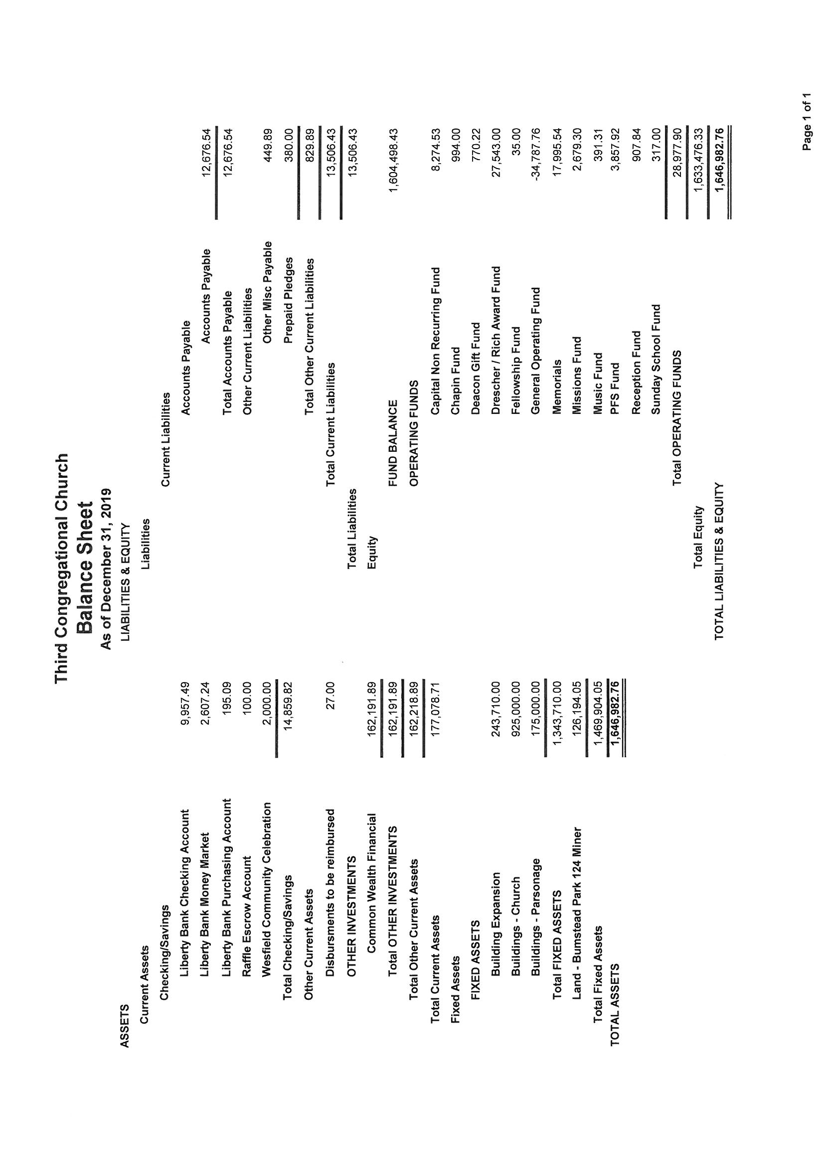

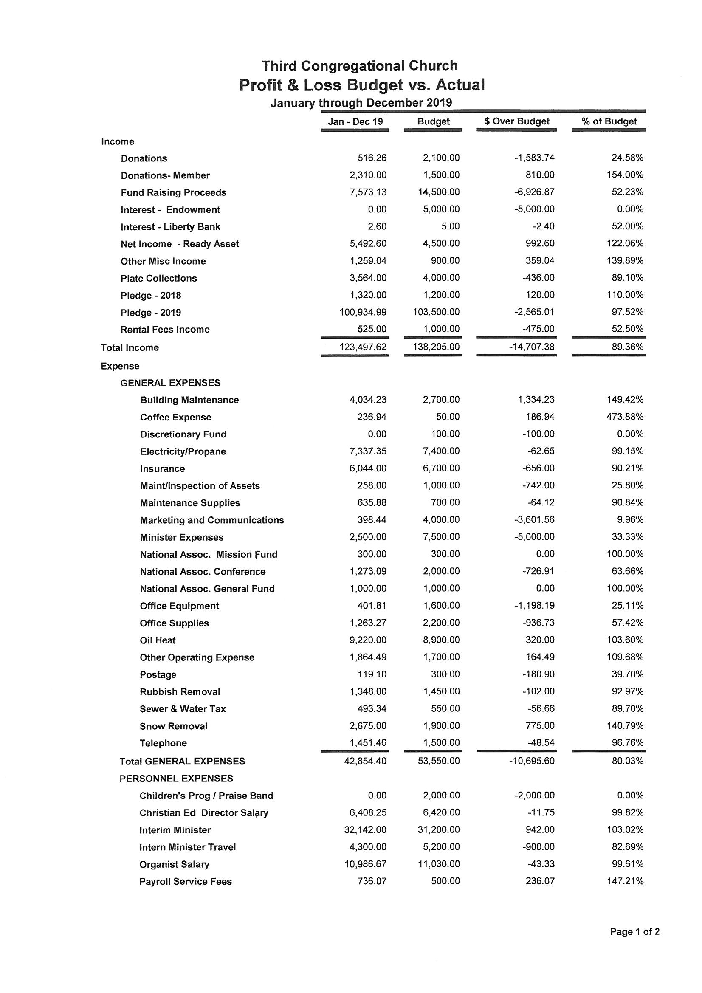

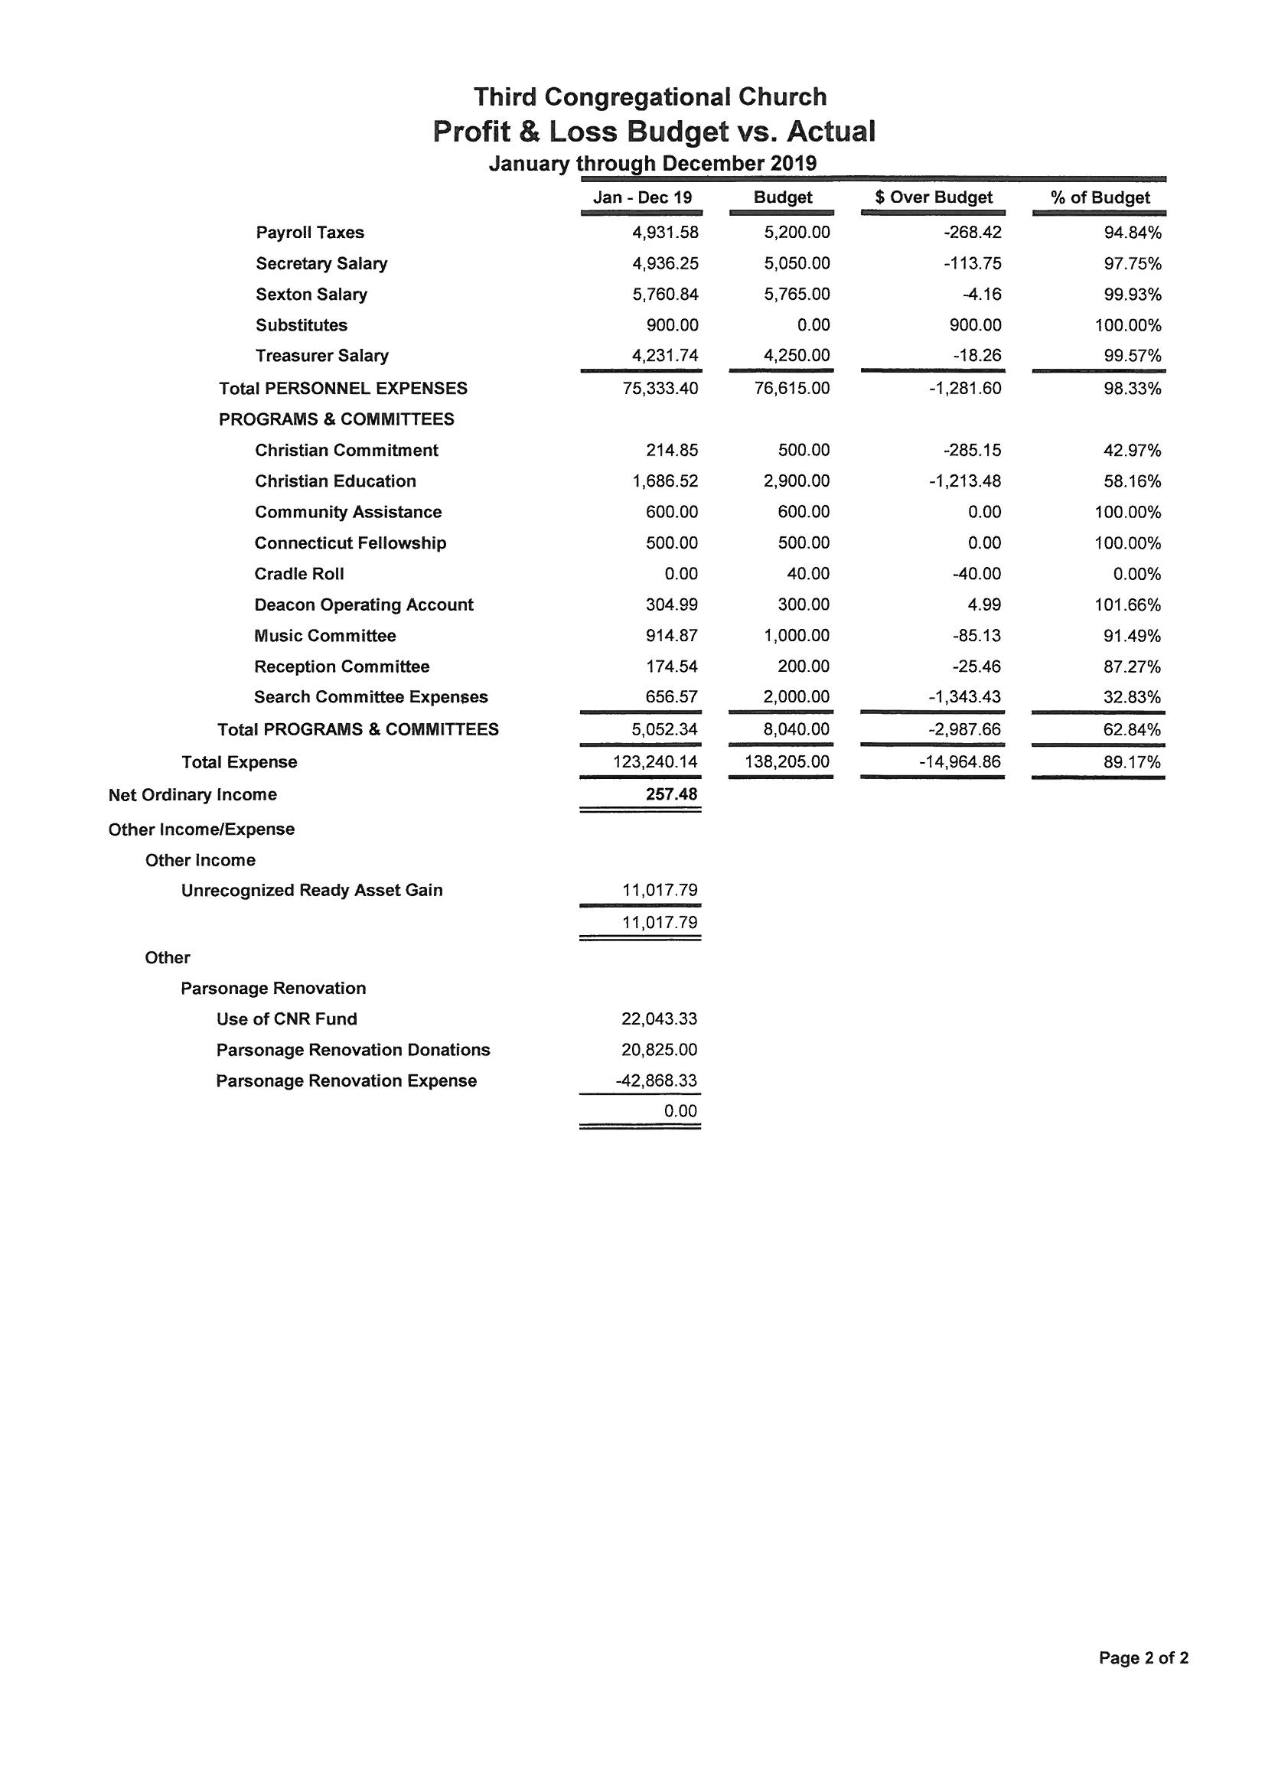

**Board of Music Report 2019**

**Members:** Lorraine Andrew, BonnieJean Connal, Leslie Coutsouridis, Cheri Czesak, Martha Deegan, James Reeves (secretary), Theresa Reeves (choir liaison & vice chair), Corrine Sternberg and Lina Vior

Where would we be without our marvelous choir. We are thankful for each member, for their dedication and willingness to share their gift of music with us each week. We look forward to hearing their beautiful noise in the coming year, as they bring to us both traditional and contemporary music. Anyone who has music in their heart is encouraged to join this important ministry.

During the summer months, a few of the choir members continued to bless us with music in the worship service, as well as soloists who shared their gifts with us.

Throughout this year, we have welcomed several special musicians who have shared their talent during worship service, many from our church family, area high schools, as well as organized groups.

During the Christmas season, the New Haven Community Quartet provided the music during worship service, followed by a short concert in the Fellowship Hall during our time of fellowship. We felt fortunate to experience the spirit of such talent, during the season of celebrating the birth of our Lord.

A week later, we welcomed the North Guilford Congregational Church Bell Choir, who blessed us with an evening concert of seasonal favorites as well as a few cultural pieces. This was followed by a gathering in the Fellowship Hall, where light refreshments and conversation were enjoyed by many.

Through generous donations, we were able to subscribe to a new music library (SongSelect) and purchase a licensing copyright agreement which gives us access to contemporary worship music and brings us in compliance with copying music. If we want to stream videos on the web, including social media, we will need to purchase an additional license.

Access to this new library has allowed the choir to add contemporary worship music to our Sunday worship services. We hope to expand this further in the coming year.

The Board continues to coordinate maintenance of the piano and organ, as needed. A new maintenance specialist was hired this year, who added a broader spectrum of services, enhancing the sound of the piano.

We look forward to another great year of supporting the music ministry of our church.

Respectfully Submitted,

Corrine Sternberg

Chairperson

Third Congregational Church  
Board of Missions and Outreach  
2019 Annual Report

 The Board of Missions and Outreach began the year on March 17 at

St. Vincent’s de Paul soup kitchen.  We served a hearty Ziti Casserole at this annual meal.  We always find those we serve, so very grateful and appreciative.  We leave feeling their gratitude and grateful we are able to help our local community.

 April 26 and 27 we held our largest fundraiser the Tag and Bake sale.  We start the Sunday before and throughout the week we unpack, sort and display all the treasures we receive.  We would not be able to hold this successful event without all the help from all our church family. We raised enough money to fund our Christmas Giving Program.

 In October we hosted the Military Whist card game.  It was a fun successful fundraising night of playing cards and fellowship.

We thank all those that donated raffle prizes and desserts.

We hosted this year’s annual Crop Walk for Church World Service. Along with Middlefield Federated and Durham Congregational we were to walk at Allyn Brook Park in Durham but due to the inclement weather had to cancel.   Even though we were not able to walk we had a special collection during the month of October and we want to thank all those who so generously donated.

Lastly in December, we prepared our annual Christmas Giving Program. This year we were able to help bring the Spirit of Christmas to two new beneficiaries. We provided donations to the Solnit Children's Center and Gilead Community Services from their Christmas wish lists. Along with the centers, we continued our annual gifting to the Eddy Home and St. Vincent’s de Paul. These shelters received gift cards, gloves, hats, socks, toiletries and cookie trays.  Each of the recipients was so grateful with heartfelt thanks of all they received.  
   
The Board of Missions would like to thank each of you for all your support, with your help we can continue to support and serve our community.  
   
Respectfully submitted by  
Leslie Hassmann   
Mary Ellen Chapin  
Co-Chairs

Third Congregational Church

Annual Report for the Board of Endowments

Year Ended December 31, 2019

**The Board of Endowments:**

Steven Pawson (Chairman)

Jay Fletcher (Secretary)

Larry Cummings

Richard Kraszewski

James Stevens

The Endowment started with a balance of: _______ **$324,582.50**

Contributions: ________________________________ **$1,188.73**

Withdrawals: _________________________________ **$1,952.94**

Realized Gain/Loss: ____________________________ **$1,683.83**

Unrealized: _________________________________ **$47,461.39**

Interest: ____________________________________ **$1,515.00**

Dividend/Capital Gains: _______________________ **$14,817.80**

Ending Balance: _____________________________ **$389,296.31**

Total Gain/Loss After Fees: _____________________ **$63,525.08**

**Notes:**

The Board met with the Financial Advisor, Anthony Assante of Egidio Assante Wealth Management quarterly and has been very pleased with the professional advice and counsel of Mr. Assante. The investments were reviewed, and changes were made as warranted. The Board remains mindful and follows the guidelines of the Investment Policy Statement.

Respectfully Submitted,

Steven Pawson  
Chairman

2019 Annual Report - Stewardship Committee

The goal set for 2019 was again fairly high but realistic. With that in mind, the committee felt that a goal of $105,000 was reasonable.

Sixty-six pledges were received for a total amount of $108,677 which exceeded our goal! Ladies Aid pledged and contributed $6,000 – kudos to them for their continued support.

Efforts included:

1. The pledge letter was revised to be more succinct. It was decided to replace the pie chart with a bar chart for the next Stewardship campaign.
2. All aspects of stewardship were stressed during the year – including volunteering within and outside of the church.
3. A poster was again used to pictorially display the progress of the pledges received.
4. An email was distributed to remind all of the use of automatic payments through their bank/credit union.

Submitted by Dolores Sutton on behalf of the Stewardship Committee:

Larry Cummings, Sharon Maloney, Bettye Nosenzo, Betty Shaw, Dolores Sutton, Martha Yardis

**Partnership for Sharing Report 2019**

For the year 2019 Randy Root served as chair for PFS. Ruth Law has continued serving as treasurer as well as advertising, along with Peggy Root. A core group of PFS members planned and organized a number of events. As always we owe a great deal of thanks to many volunteers who work so hard to make these events so successful. In addition, we appreciated seeing many new faces volunteer for many of our events. We want to especially thank Pilgrim Fellowship members, as well as grandchildren and friends of our core members. PFS is successful because of all the help we receive.

Events of 2019 included:

**Corned Beef Dinner** Saturday, March 7th

**Military Whist** Thursday**,** May 21st

**Build Your Own Pasta Dinner** Saturday**,** April 18th

**Ice Cream Social** Friday**,** July 17th

**Pork Roast Dinner** Saturday**,** October 17th

**Breakfast with Santa** Saturday**,** December 5th

As always, special thanks go to Russ and Leslie Hassmann for provision and maintenance of signs. Our thanks also to Jeff Yardis who provided digital picture taking for Breakfast with Santa. Lastly, thanks go to Santa for his visit.

We began the year with a carry-over of $3,539.25 and completed the year with a balance of $3,857.92. A pledge of $3,000 was made to the general fund.

We continue to receive many compliments with regard to our quality of food and courtesy provided for our dinners. All of our events continue to help render a high visibility of Third Church to the community and surrounding areas.

Randy Root, Chairman

**Westfield Ladies Aid Annual Report 2019**

President Leslie Hassmann

Vice President  Betty Shaw

Treasurer Dolores Sutton

Secretary Sue Charter

Meets the fourth Thurs of the month at 10 am for crafts and good company.  The society has 18 members.

This year we welcomed two new members Susan Paul and Jane Palmer.   While losing two members Laurine Sierpinski and May Rutledge.

The Strawberry Festival held in June was very successful which enabled us to pledge $6,000 to Third Church we also supported   Amazing Grace, Wreaths Across America Crop Walk, third church missions, garden, Fellowship Tea, and Warm the Children.

Get Well, thinking of you, birthday, and sympathy cards were sent.

Easter and Christmas plants put in the sanctuary and then taken to our shut-ins.

A summer outing at the Fish Tale and Christmas party at the Wooden n’ Tap was enjoyed by all

The Ladies had a good year.   We thank all who helped us, without you this is not possible.

Sue Charter, Secretary

**Reception Committee**

The Reception Committee had a busy year. We had receptions after the following Memorial Services: January 19, Jeffrey Meehl; March 23 for Larry Redmond; and October 19 for Robert Paul.

We had the following celebrations servicing cake: March 10 – Reverend Nancy Lois’ birthday; May 5 for new members (Jim and Lois Stevens, Al & Carol Baron and Neil Dokurno) and December 1 to celebrate Reverend Nancy Lois’ first Sunday as full time Pastor.

We held a reception for those attending the meeting of the FNCCC on October 19.

We thank all who helped and contributed food for these gatherings.

Cookie Stojak and Lorraine Andrew Chairpersons

Members: Danielle Czesak, Ruth Law, Alberina Fletcher, Peggy Root, Sara Pawlow, Betty Shaw, Joyce Cummings, Lina Vior and Gayle Peterson.

**Flower Committee Report 2019**

The flower committee sees that flowers are placed in the sanctuary for Sunday worship services weekly. Plants for Easter and Christmas are ordered and arranged in the sanctuary. Anyone who wishes to have flowers placed in memory or in honor of loved ones may do so, just contact any member of the committee.

Arlene Wilson

Virginia Hodge

Sue Charter

**Garden Report 2019**

The garden is growing and getting to a point of just maintaining. Of course, there are always annuals to plant in the spring and raking and cleaning out.  Thank you Al Baron for disposing of the chairs that weren't safe to use. Thank you to all the men that helped through the summer. I appreciate it.  Also, thanks to ladies aid for donating money to buy annuals for the urn and other containers, as well as a few plants.   
     Next year our goal is to finish the back path, lay some nice stone, and hang some decorative things on the fence, a few other small things to be done. Come and enjoy the garden next spring and summer.  With everyone's help, we will have a beautiful garden to meditate in and enjoy during the season. If anyone would like to help, we could always use some extra hands. 

Betty Shaw, Garden Chair

**MM&C**

**The Membership Marketing and Communication Committee** was formed to address the reality that we have about 30% fewer members of our church than we did 15 years ago. This is not a problem that is limited to just our church, but many others. The goal of MM&C is to be more conscientious in the care and consideration for our members – each and every member is vital to our future and we want everyone to feel valued and included in our church family. Next, we want to be welcoming to new comers and to have a consciousness that all of us are integral to helping Third Church gain new members. Lastly, we want to have better communication efforts so that we are harvesting every opportunity to get the word out about Third Church again maintaining a focus on both our members and the community at large.

This work is not limited to those who participate in the committee – many of our tasks are outlined in the Bylaws of Third Church, and in the responsibilities of officers, our Minister and our Board of Deacon’s. We believe the MM&C committee has been successful in calling attention to these procedures and that they are functioning better than they were in the recent past. We now have a defined list of members; an online membership directory; and a growing database of “friends of Third Church” and we communicate with them via email. Updates and improvements have been made to our church website and our signage has increased visibility as we have doubled the number of signs and lengthened the time period that they are on display.

Our work has just begun, and with a newly settled Minister our hope is to gain some real traction in the coming year.

-Direct Mail Campaign: we want to send an invitation to every new homeowner in Middletown and Cromwell to welcome them to our community and encourage them to visit our church.

-Email Campaign: We want to continue to grow our list of “Friends of Third Church” by continuing to gain the email addresses of visitors to our events. We want to find ways to engage with the casual visitors and remind them of upcoming events and perhaps engage them to come to a worship service.

-Our website is the new front door of our church and a recent new member revealed that they first checked us out online and they liked what they saw and decided to give us a try. We want our front door to be welcoming and to be reflective of the scope and vitality of Third Church.

We are 247 years old – and we need to be 24-7 about growing Third Church. If you are interested in participating, please let me know.

All my best,

Jeff Yardis

Membership, Marketing & Communication

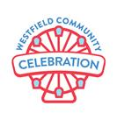

The Westfield Community Celebration - 2019

Planning Team Members: Dean Coutsouridis, Leslie Coutsouridis, Danielle Czesak, Lou Deegan, Jeff Yardis, Randy Root, Peggy Root, Kim Kennedy, Ruth Law, Mary Ellen Schildwaster, Ellie Hojda, Cookie Stojak, Corrine Sternberg, Nate Chapin

Our goal for the WCC, was to build on the success of our previous event.

2019 event planning began in March and continued with regular meetings up to the event, which was held on the weekend of September 21/22.

This was a huge effort. Our committee broke out into 16 sub-committees, each with a full plate of work to do. They included: Administration, Advertising/Marketing, Bake Sale, Beer Tent, Basket Raffle, Cash Raffle, Entertainment, Food, Grounds, Insurance, Parking, Pig Roast, Sponsors, Treasury, Vendors, and Volunteer Management.

In addition to our core planning group, we had nearly 100 volunteers who donated their time and resources to the event.

Unfortunately, we didn’t do as well as we had hoped financially. The net profit for the event was only $1,900.  Low attendance seemed to be the driving factor in what kept our income down. Nevertheless, I still consider the event a success. For one thing, we didn’t lose money.  More importantly, the coming together of our members and friends for hard work and good fun is something to celebrate.

Thanks to everyone for all of your hard work and dedication toward putting on this event. And special thanks to Randy Root, without whom this event would not be possible.

Paul Kennedy, Event Chair

Search Committee – Annual Report February 2020

The Search Committee was formed by the Standing Committee in September 2018. The committee was very during the past year. Several sub-committees were formed to concentrate on the following important tasks:

Congregational Questionnaire  
The focus of this group was to formulate a meaningful survey to gather information about what we consider important traits to have in a minister and to get a consensus of where we’d like to be in the future as a church. It provided important feedback which served as the basis of the actual search itself.

Technology & Social Media  
This group was responsible for evaluating our current available technology as well as recommend enhancements to help make us more efficient and effective. Some of these technologies include teleconferencing and video conferencing (Go to Meeting) to use during candidate interviews.

Church Information & Profile (CIF)  
The NACCC (National Association of Congregational Christian Churches) was one of the best resources we had for support and information about how to conduct our search. The CIF or Church Information Form, is a tool used by the NACCC to provide important information about our church to connect us to potential minister candidates. Some of the information gathered on the form includes demographics about our congregation and the Middletown community, what boards and committees we have, as well as our financial position. More importantly, it contains our church covenant, theological position and what we’d like to see in our new minister.

Interview Questions and Scorecard  
This group was responsible for reviewing the results of the Congregational Questionnaire and creating appropriate candidate interview questions from those results. We wanted to be sure the potential candidates would meet the and fulfill the needs of the congregation. They also created an interview scorecard to help foster objectiveness when reviewing the actual interviews.

Throughout the process, the Search Committee received an initial total of 5 candidates via the NACCC’s job posting website. The Minister Information Forms that were submitted are quite lengthy and inclusive. Three candidates were selected to interview either in person or via live video (Go to Meeting). All interviews were recorded so any committee members that were absent from the original interview could review the recording. The Search Committee invited one candidate to return for a 2nd interview and subsequently was voted by the committee to be called to serve Third Congregational Church as its full-time minister, which was accepted. Unfortunately, the candidate later made the decision to withdraw. The Search Committee received interest from a 6th candidate. This candidate was interviewed but it was decided not to move forward in the process with this individual.

As we were not working with any potential candidates at the time, the committee decided to suspend any further search: we determined that the search had been exhausted. We had received several positive comments from the congregation regarding our interim minister, Nancy Lois. Rev. Lois and the Search Committee together entered conversations to explore the opportunity for her to serve as our settled pastor. The committee and Nancy agreed that the process the Search Committee had used for other candidates would be the same and that any outcomes would be made with mutual guidance and respect for the other.

The Search Committee reviewed Rev. Lois’ Minister Information Form in detail and followed with an in-person interview. The committee voted unanimously to call Rev. Lois to serve as the full-time minister, which she accepted. Following successful negotiations of the Terms of Call with the Board of Trustees, a special meeting of the congregation was held. Rev. Nancy Lois was voted as the full-time minister of Third Congregational Church by the congregation on October 20, 2019, effective December 1, 2019. The Search Committee was later disbanded.

Submitted in Faith,

Martha Fetter  
Chair, Search Committee

**Bylaws Committee Annual Report - 2019**

**Committee members:** Don Keathley, Dave Tycz, Danielle Czesak, Corrine Sternberg, Paul Kennedy

The bylaws committee met several times throughout 2019, both in person and through email communication. Several sections of our bylaws were reviewed and discussed using the following as general guiding points:

* Bylaws must include articles required by law in support of the Church’s incorporation and compliance to state law and tax law
* Bylaws should be simple and not unnecessarily restrict a church’s ability to adapt to changing environments
* Bylaws should avoid dictating the operating procedures of individual boards and committees
* Bylaws should serve the church, not the other way around

A draft of the proposed changes was presented to the Standing Committee at their November 2019 meeting for a period of public review. Feedback from the Standing Committee was reviewed, discussed and revisions were made to the proposed changes.

The committee makes the following recommendations:

1. The proposed changes are submitted to the congregation for approval at the Annual Meeting on February 2, 2020. The changes are delineated below and contained in the attached copy of the bylaws.
2. Continue the Bylaws committee to consider:
   1. Updates to Bylaws Section 1-2: Duties of Members. The language in this section is outdated. The committee recommends further review and rewording to better reflect the requirements of our membership.
   2. Sections 3.4 through 3.10 require review and updating.
   3. Other areas that may be identified.

Proposed Changes:

1. Sect. 1-3. MEMBERSHIP ADMINISTRATION: **Change** ‘Membership Committee’ **to be** Membership Administrative Committee’ in 2 places.
2. Sect, 2-6. TREASURER: Change last sentence in part **From:** ‘The Treasure shall make a ***complete*** report of ***all*** receipts and expenditures…….’**. To read:** ‘The Treasurer shall make a ***summary*** report of receipts and expenditures……’
3. Sect. 2-8. BOARD OF TRUSTEES: In the fourth paragraph, change the first sentence in part **From:** ‘The Board of Trustees, in concert with its ex-officio members and the Treasurer, shall prepare a preliminary budget ***by September 15th of*** each calendar year based on the…..’ **To read:** ‘The Board of Trustees, in concert with its ex-officio members and the Treasurer, shall prepare a preliminary budget ***to support the stewardship campaign*** each calendar year based on the…..’
4. Sect. 2-9. DIACONATE: Change the first paragraph **From:** ‘There shall be ***fifteen (15) members*** of the Diaconate who shall be at least 16 years of age, five (5) of whom shall be elected at each Annual Meeting to serve a term of three (3) years. ***No Diaconate member shall serve*** ***more than two (2 )full consecutive terms without a lapse of one year***.’ **To read**: ‘There shall be ***a minimum of nine (9)*** members of the Diaconate who shall be at least 16 years of age and whom shall be elected at each Annual Meeting to serve a term of three (3) years.’
5. Sect. 2-13 (b).BOARD OF ENDOWMENTS: Change the paragraph in part **From:** ‘….by two-thirds (2/3) vote of the ***congregation*** at a duly called…**’ To read:** ‘by two-thirds (2/3) ***affirmative*** vote ***of those*** ***present*** at a duly called………’
6. Sect. 3-2. STANDING COMMITTEE: Under item 2., **delete** Fellowship Committee
7. Sect. 3-8. DELEGATES: In the first sentence, **delete** the word ‘***fellowship***’ and **replace** with ***‘Association of Congregational Christian Churches (NACCC)’*** and at the end of thesentence after the word churches **add *‘(FNCCC) meetings.’***
8. Sect. 3-9. DIRECTOR(S) OF USHERS: **Remove** ***‘(s)***’ from section title, Change paragraph, in part, **From**: ‘There shall be ***one, or more, Director(s***) who…..’ **To read:** ‘There shall be ***a Director of Ushers*** who…’
9. Sect 3-11. FELLOWSHIP COMMITTEE: **Delete** this paragraph in whole
10. Sect. 3-12. NOMINATING COMMITTEE: Change Item 5. In part, **From**: (***Five*** for 3 year terms each) **To read:** ***(A/R*** for 3 year terms each) and Change Item 19, in part, from ‘….(four)’ to read ‘….(Four ***plus the Vice*** ***President***)’ . Also **Delete** ***Item 18 (Fellowship Committee***)
11. Sect. 4-3. SPECIAL MEETINGS: Change the second sentence **From:** ‘At least five(5) days prior to the date of such meeting, a notice of the date, time and place of such special meeting must be delivered via ***the Church’s normal written communication means to members*** , announced during worship service ***and appear in a local newspaper***’ **To read**: ‘At least five(5) days prior to the date of such meeting, a notice of the date, time and place of such special meeting must be ***delivered via electronic mail or U.S. Mail to each Regular*** ***(voting)*** ***Member and*** announced during worship service.’
12. Global edit: In all places where the word ‘***Chairman***’ occurs, it is to be **replaced** with the word ‘***Chair’***

Respectfully and In Faith,

**Troop 16 Report**

Troop 16 meets at the church on Sundays from 4pm to 5:30pm. The troop has 40 boys and 5 patrols under the leadership of Scoutmaster, William Shea, with 6 ass’t scoutmasters, 5 junior leaders.

During the year the troop attend the Fall Camporee, Klondike Derby, Spring Camporee, and winter outing with the Cub Scouts from Pack 43.

Held 3 Court of Honors and 2 Eagle Court of Honors.

During the summer the troop went to Camp JN Webster in Ashford, CT with 22 scouts and 12 adults for week one and 17 scouts attending the second week. All in all they spent 2 weeks at camp.

The troop sells popcorn and has a Ham Dinner to buy equipment.

Thanks to Third Church for its sponsorship for 75 years.

Anyone interested in visiting or becoming a member is always welcome.

Robert Olenick, Chairman

**Cub Scout Pack 43**

2019 Annual Report

The Cub Scouts of Pack 43 had a successful year in 2019. We recruited 8 new Cub Scouts and 3 new adult Leaders. We added a new Tiger Den and new members to every rank. Also, for the first time, we added a Lion Den, which is structured for Kindergarten-aged youth. Six of our Arrow of Light Scouts will cross over to become Boy Scouts in Troop 16 at our Annual Blue and Gold Celebration in March, 2020.

Community Service

In 2019, Pack 43 continued our commitment to community service. Highlights included:

* Our continued tradition of helping to place American flags at the Miner Street Cemetery on Memorial Day.
* Making greeting cards and sang Christmas carols at the Luther Ridge (our 5th year).
* Assistance with the Third Congregational Church Community Celebration.
* Leave-No-Trace hiking events nearly every month of the year at trails located throughout the greater-Middletown area.

Hiking and Camping

Pack 43 also continued to have a very active outdoor program, which included overnight camping, hiking, and participation in Council summer camps. We also continued our “Hike of the Month” club with monthly hikes that explored some of the area’s less well known open spaces and hiking areas. These hikes included the Scovill Loop, Gillette Castle (where we also toured the castle to see their holiday decorations), Wilcox Conservation Area, Highlawn Forest, Deer Lake, Airline Trail, Spiderweed Preserve, Portland Cobalt Mines and the Guida Preserve. Check our Pack 43-Middletown Facebook page and join us for a hike!

High Adventure Trips

In May, our Pack took a weekend high-adventure trip to Salisbury Beach State Park in Salisbury, Mass. We also took part in a whale-watch cruise and visited the village of Newburyport, Mass.

In September we traveled by train to Manhattan to hike the High Line trail and visit the Freedom Tower. For many of the Scouts, it was their very first ride on the subway!

Other Activities

In addition to regular Pack meetings, our calendar also included a number of fun and interesting events:

* A holiday excursion to the Connecticut Trolley Museum in Warehouse Point, CT.
* A “Raingutter Regatta”, where the boys built and raced sailboats in rain gutters.
* Our annual Pinewood Derby, where we enjoyed building and racing cars.
* Two Rocket Days at Haddam Meadows State Park.
* Return of the Halloween Haunted Woods.

In addition to our scheduled Pack events, each of our Dens planned and participated in their own activities and service projects throughout the year. Our Cub Scout Pack strives to make all of the activities fun, rewarding and educational for all of our Cub Scouts and their families.

As we complete our 58nd year, we would like to thank our Chartered Organization, the Third Congregational Church, for their continued support. We would also like to extend a special thanks to our Chartered Organization Representative, Nate Chapin, and our Unit Commissioner, Bob Olenick and Pastor Nancy Lois for their support and assistance throughout the year.

Respectfully,

Jeffrey Clark Cubmaster, Pack 43

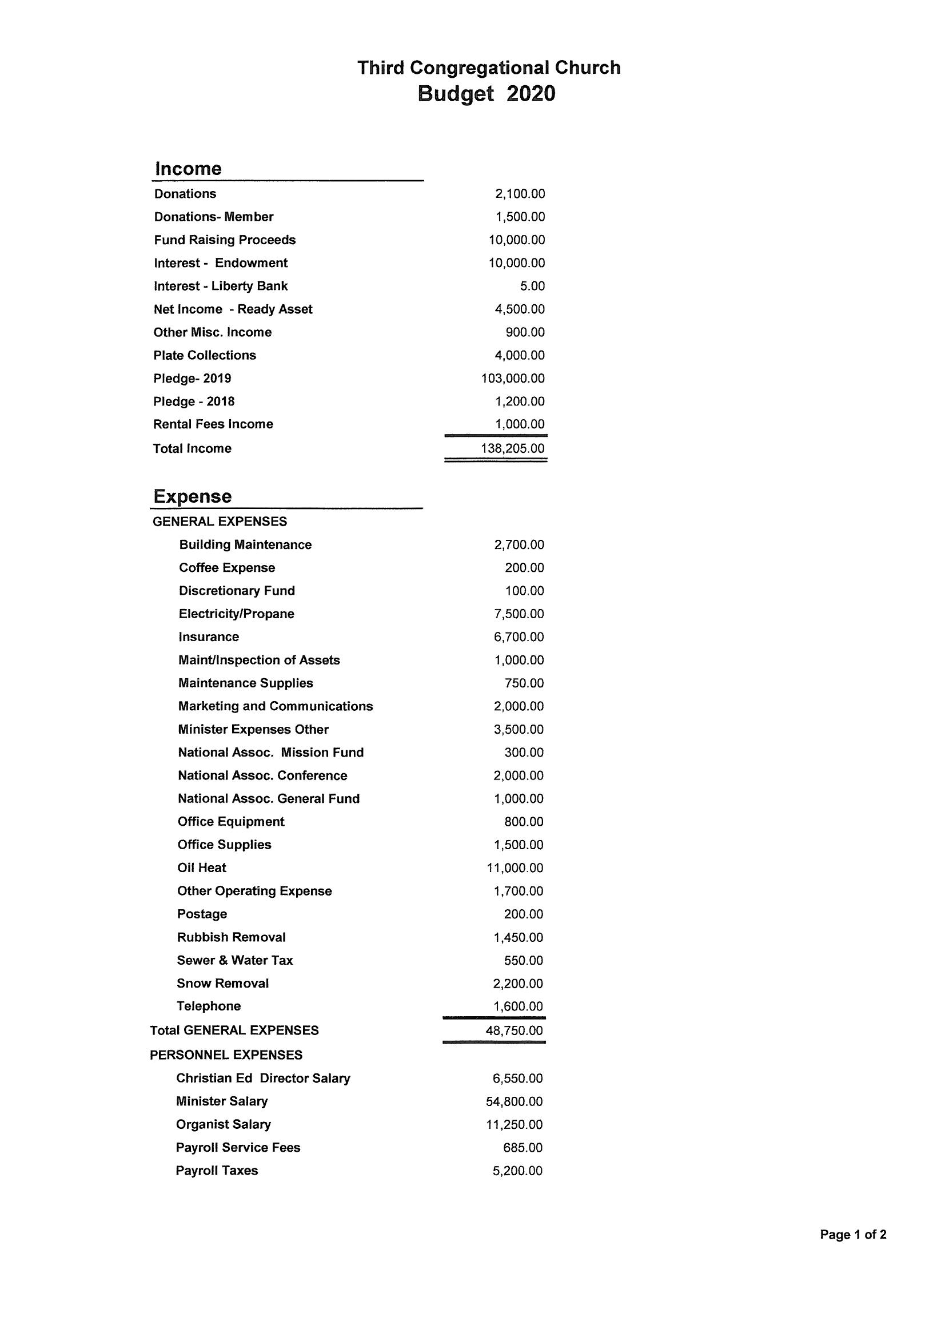

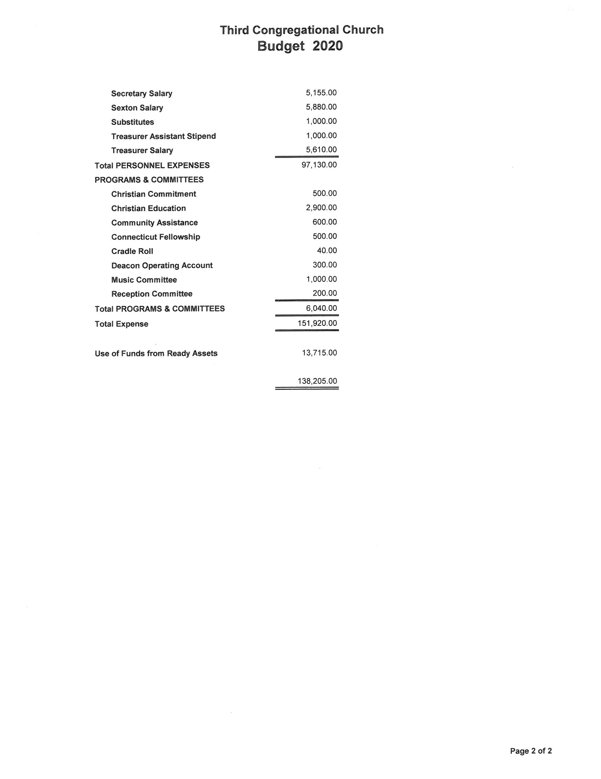

**NOMINATIONS FOR 2020**

**President:** Fred Shiffer

**Vice President/President Elect**: Mary Ellen Schildwaster

**Corporate Secretary**: ______________________

**Asst. Corporate Secretary:** ______________________

|  |  |
| --- | --- |
| **Board of Trustees** - 6 Regular Members (3-Year Term, 2-Term Limit) | |
| Nominees | Incumbents |
| Steve Pawson (filling in for Fred, Jan 2021)  Martha Fetter (2nd-2023)  Dana Andrew (1st-2023) | Randy Root (2nd-2022)  Dolores Sutton (1st-2022)  Russ Hassmann (2nd- 2021)© |

|  |  |
| --- | --- |
| **Diaconate** - 15 Regular Members (3-Year Term, 2-Term Limit) | |
| Nominees | Incumbents |
| Shawn Tycz (1st-2023)  Patty Mailhot (1st-2023) | Martha Deegan (2nd—Jan 2021)  Peggy Root (2nd—Jan 2021)  Nate Chapin (1st – Jan 2021)  Linda Rec (1st – Jan 2021)  Corrine Sternberg (1st – 2021)  Ken Joy (2nd-2022)©  Jeff Yardis (2nd-2022)  Chris Tessman (2nd-2022)  Cheri Czesak (1st-2022)  Erika Hojda (1st-2022)  Linda Rec (1st-2021) |

|  |  |
| --- | --- |
| **Board of Endowments** - 5 Regular Members (3-Year Term, 2-Term Limit) | |
| Nominees | Incumbents |
| Al Baron (1st-2023)  Steve Pawson (2nd-2023) | Rich Kraszewski (2nd – Jan 2021)  Jay Fletcher (1st-2022)  Jim Stevens (1sat-2022) |

**Nominating Committee -** Vice President + 4 Regular Members (1-year term, 2-term limit)

Mary Ellen Schildwaster (1st), Shawn Tycz (1st), Danielle Czesak (1st), Peggy Root (2nd), Linda Bonneau (2nd)

**Members At Large** - 2 Regular Members, (1-year term)

Sue Charter, Linda Bonneau

**Boards** (open membership*)

**Christian Education** Kim Kennedy,© Johanna Tessman, Ellie Hojda, Janice Drescher, Jennifer Smith, Collin Kennedy, Elizabeth Joy, Erika Hojda

**Missions & Outreach** Mary Ellen Chapin©, Lina Vior, Leslie Hassmann©, Sue Charter, Shawn Tycz, Linda Bonneau, Kim Kennedy, Nate Chapin, Gladys Szell

**Music** Lina Vior, Lorraine Andrew, Cheri Czesak, Martha Deegan, Leslie Coutsouridis, Theresa Reeves, James Reeves, Neil Dokurno, Corrine Sternberg©.

**Committees** (open membership*)

**Stewardship Committee** Dolores Sutton, Larry Cummings, Martha Fetter, Betty Shaw, Sharon Maloney

**Reception** Lorraine Andrew©, Lina Vior, Alberina Fletcher, Sara Pawlow, Cookie Stojak, Ruth Law, Danielle Czesak, Gayle Peterson, Betty Shaw, Peggy Root

**Flower** Sue Charter, Virginia Hodge, Arlene Wilson

**Coffee** Mary Ellen Chapin, Lina Vior, Sue Charter, Betty Shaw, Linda Bonneau, Jane Palmer, Ellie Bartlett, Lydia Hodge, Ruth Law, Nate Chapin

**Partnership For Sharing** Mary Ellen Chapin, Randy Root©, Peggy Root©, Lina Vior, Leslie Hassmann, Larry Cummings, Virginia Hodge, Betty Shaw, Tony DiMauro, Barbara DiMauro, Ruth Law, Tom Law, Brian Albert, Lori Albert, Nathan Chapin, Roger Tryon, Jeff Yardis

**Ushers** Lou Deegan, Bill Wilson, Dolores Sutton

**Cradle Roll** Mary Ellen Chapin, Christine Gerardi

**Bylaws** Don Keathley, Dave Tycz, Corrine Sternberg

**Membership, Marketing, and Communication**

Jeff Yardis©, Corrine Sternberg, Russ Hassmann, Johanna Tessman, Jeff Clark, Dave Tycz, Peggy Root, Paul Kennedy, Danielle Czesak, Don Keathley, Dolores Sutton

**Fellowship**  Jeff Yardis, Sharon Maloney

**Delegates**

**NACCC FNCCC**\*\*

Kim Kennedy, (tbd) Corrine Sternberg, Jim Stevens, Paul Kennedy

*Boards and Committees with “Open Membership” may have members added at any time during the year.

**FNCCC-The Fellowship of Northeast Congregational Christian Churches